**Date : 11-09-2020**

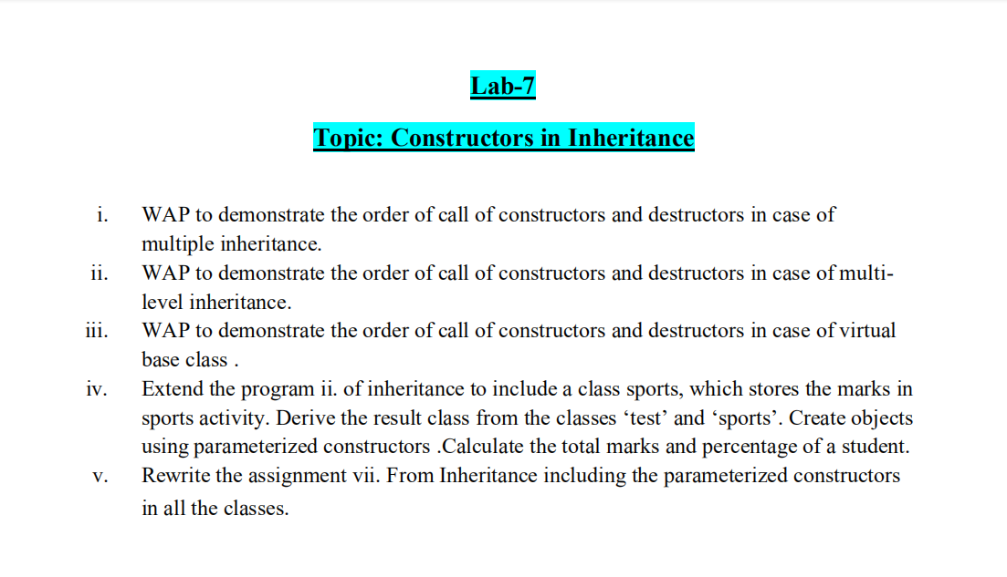

1.

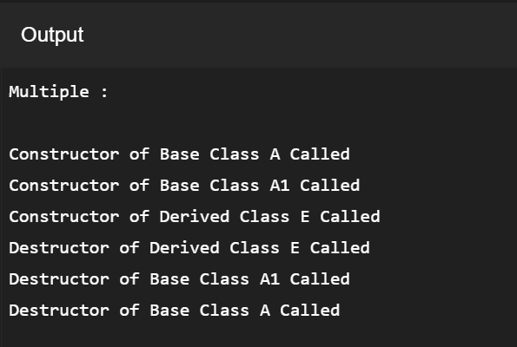

2.

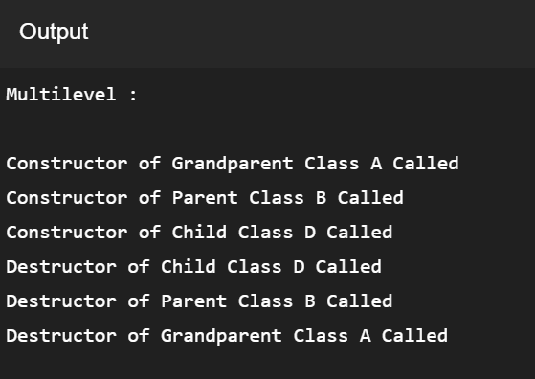

3.

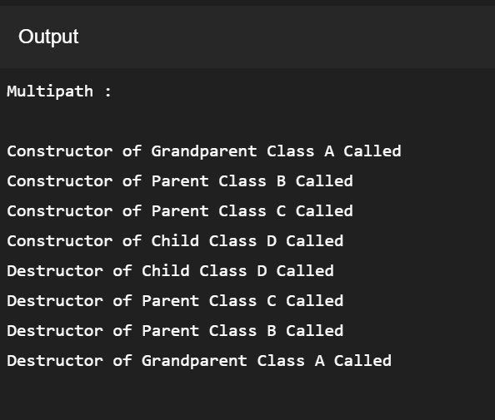

4.

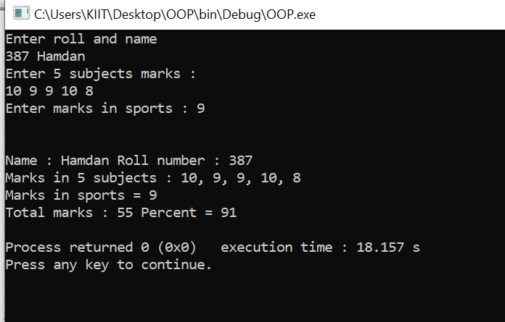

5.

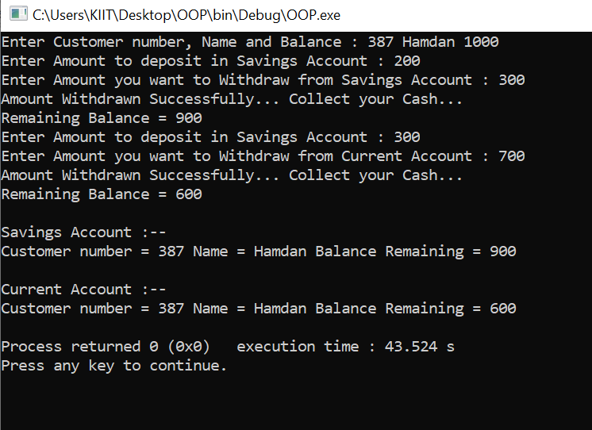

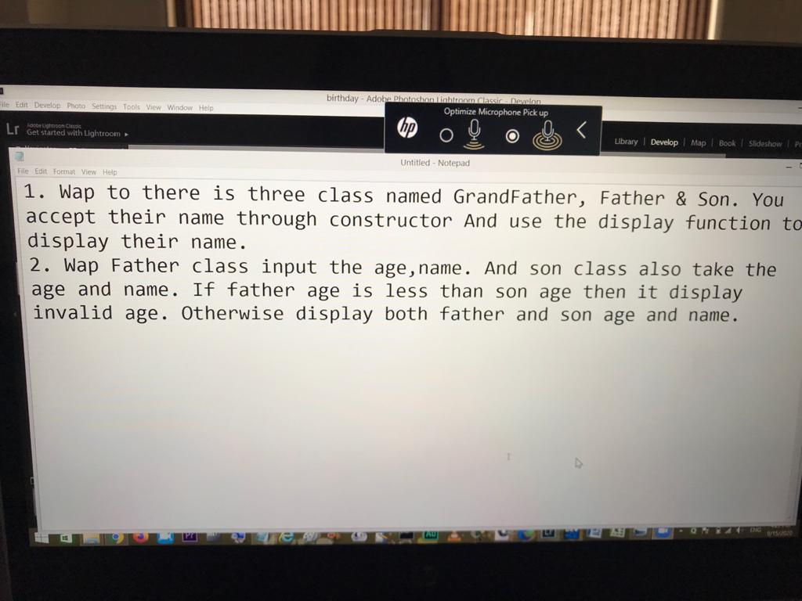



OUTPUT :

Enter name of Grandfather : Siraj

Enter name of Father : Hammad

Enter name of Son : Hamdan

Grandfather's name : Siraj

Father's name : Hammad

Son's name : Hamdan

2.

OUTPUT :

INPUT :

Enter Father's name and age : Hammad 50

Enter Son's name and age : Hamdan 20

OUTPUT :

Father's Name : Hammad

Father's Age : 50

Son's Name : Hamdan

Son's Age : 20